# **BLOCKCHAIN, CRYPTOCURRENCY, AND REAL ESTATE:**

**THE CURRENT SITUATION AND PROSPECTS FOR THE NEXT 5 YEARS**

By

Robert A. Simons, Ph.D.

Levin College of Urban Affairs, Cleveland State University

[r.simons@csuohio.edu](mailto:r.simons@csuohio.edu)

and

Samuel T. Simons

Smith School of Business, University of Maryland, College Park

ssimons@umd.edu

**ABSTRACT**

Blockchain technology is a platform for transactions and investment. It includes Cryptocurrencies, of which there are dozens of investment vehicles. Bitcoin and Ethereum are the best known. Crypto is an emerging asset class and offers some portfolio diversification benefits and attractive return rates. Some crypto investments are stablecoins and are tethered to underlying currencies like the US dollar. Blockchain allows ease of access and transparency and provides a cloak of anonymity, which may be incompatible with owning real estate, which generally has ownership and transactions as public records.

This paper provides a brief primer on the intersection of blockchain, cryptocurrencies, and real property. It reviews the various ways that these emerging technologies and instruments are used in real estate investment today. We investigate a blockchain-oriented investment platform, RealT, and report on their business model and customer-servicing interface. Their model offers tokenized real estate to a wide range of qualified investors, and many of the occupied houses feature secure cash flows in the form of Section 8 tenants. If properly developed, the model appears sustainable and can rejuvenate inner-city residential property markets and open the door for a greater ROE for not-for-profit groups.

**Key words:** blockchain, cryptocurrency, tokenization of real estate, smart contracts

**INTRODUCTION**

Bitcoin's meteoric rise is well known, but it is just one of many cryptocurrencies, which are subsumed under blockchain technology. These have achieved prominence but are still highly controversial. Depending on whom you talk to, blockchain and cryptocurrency either herald a revolutionary new approach to commerce or raise the specter of rampant speculation and corruption. Nevertheless, these innovations have made massive strides toward mainstream adoption. Major firms such as J.P. Morgan, Facebook (Libra, now Diem), and Alibaba have launched stablecoins (digital dollars) to allow seamless digital payments. Central banks the world over are considering the tokenization of their fiat currencies, i.e., those directly connected to a nation with an existing currency. When applied to the appropriate applications, blockchain technology has proven its ability to deliver concrete advantages such as security, anonymity, and transparency over traditional system management systems. We address how blockchain or cryptocurrencies (crypto), or both, are compatible with ownership of the real estate in the US. What models exist, and which are likely to emerge soon? We focus on tokenization (securitization) of real estate in one case study (RealT) and how it originated, was brought under a blockchain management system, and provides returns to investors. This also offers scalable returns for property originators (owners of housing rental units) and blockchain management companies. We also look at potential social benefits to the communities that host clusters of these tokenized properties.

The real estate market is a prime target for blockchain because it can be managed publicly, even though individual ownership units are pseudo-anonymous. The issuing party has done some identity vetting (RealT knows who their customers are, but an outside observer could not determine their identity without forensic analysis). Still, to a public onlooker, all they can see is an internet identifying wallet number. Crypto's disruptive potential is primarily as a very fast-growing medium of exchange that appears to offer some potential tax advantages, sports a wealth of information that usually is publicly accessible, relies on clearly defined contracts to complete transactions, and can be adapted to become highly liquid. In this context, the integrity-protected data storage and process transparency offered by blockchain technology is potentially a perfect fit for the real estate industry, while crypto is more of a sidebar.

# **BLOCKCHAIN OVERVIEW**

The blockchain is a set of separate computers that work together to maintain a ledger or transactions list. It can do whatever a regular computer can do, albeit slower but more secure. Bitcoin, built on the first blockchain, is essentially a numbered bank account, but all transactions are publicly broadcast. Ethereum, the largest blockchain, allows for users to send executable code along with transactions. These are called "Smart Contracts'' and allow for programmable money and assets. Everything sent is irreversible and permanent in the sense that it is in a public domain that can’t be wiped clean.

## **Cryptocurrency Overview: Myth vs. Reality**

Bitcoin and Ethereum are two of the most well-publicized cryptocurrencies, but dozens of other crypto assets are also available, and some (known as stablecoins) are tethered to other mainstream currencies including the US dollar, Euro and gold. Below are some common misconceptions and rumors spread about digital currencies at large:

**Claim:** Bitcoin is anonymous. **Fact:** On the first level, yes, but you can peel back the onion

**Claim:** Bitcoin has no intrinsic value. **Fact:** value is set by supply and demand

**Claim:** Crypto is used to evade taxes. **Fact:** perhaps, but tax avoidance and tax evasion are different. And most taxes are avoided with the use of cash, which is widely circulated.

**Claim:** Bitcoin's only used for illegal things. **Fact:** Some uses are unlawful, but it pales in comparisonwith the use of US $100 bills.

These myths have been propagated by large banks, short-sellers, central government regulators, and others unsure of how to regulate or control this emerging asset class. To give some background about bitcoin and fiat currency, for every dollar in bitcoin laundered, $800, specifically cash, are laundered (CoinTelegraph 2020).

But what is fiat currency, and where do we derive its value? What is a cryptocurrency? Bitcoin is a digital store of value, tied to an alphanumeric string or an address. Like Swiss numbered bank accounts, at the end of the day, it presents itself as outwardly anonymous, but that veneer can be revealed with enough effort. Whatever exchange you created your crypto wallet on (e.g., your bank account where you hold your crypto assets), the people that you have sent and received bitcoin from could identify you if needed. If the federal government, or a skilled foreign or domestic hacker wants to find out who is associated with a given address, they can.

# **Centralized vs. Decentralized Finance and Real Estate Investment**

Out of the ashes of the great recession, a financial revolution featuring bitcoin has evolved and brought forward a new economic system based on blockchain technology and decentralization. One familiar traditional, centralized, and predominant public real estate investment platform is the REIT (Real Estate Investment Trust). REITs are a securitization of a real estate portfolio and are publicly listed on many securities exchanges. It has a been popular way for institutional and retail investors to gain exposure to real estate markets and their cash flows. While REITs can feature both debt and equity, we focus on the equity side here, acknowledging other ways to invest in real estate debt (CDOs, Fannie Mae, etc.).

Historically speaking, the REIT has proved to be robust. REITs have allowed real estate markets exposure to individual, non-accredited investors on centralized public (stock) exchanges. Because funds and entities can be listed on a public stock exchange, the liquidity for any given fund is an order of magnitude larger than any private investment. A stock exchange, such as the NYSE can process hundreds of thousands of transactions a second, creating a technological race to the bottom, where firms compete on how fast they can fill orders, measured milliseconds. For example, Goldman Sachs has spent hundreds of millions of dollars in infrastructure investment to shave 21 milliseconds off their transaction speeds (CNBC 2019).

Looking back at the 2009 financial crisis, we often like to blame the Collateralized Debt Obligation, an asset-backed security, which the darling of the financial sector. Academics and professionals devised a new technology that allowed the packaging of fixed-income securities and paired it with a complementary derivatives market. Caught in the moment and flush with greed, risks were underemphasized, and due diligence was ignored. The great recession was based in the US, which had the world's largest, most advanced, innovative, and regulated financial markets. If the government could not prevent rampant greed and market failure, then perhaps a non-governmental currency was the answer?

In the aftermath of the great recession, Satoshi (2009) announced the first bitcoin transaction in The Times: “Chancellor on brink of second bailout for banks – the Bitcoin Genesis Block” A new generation of finance was born[1].

Exhibit 1 shows the timeline for blockchain development, coincident with bitcoin, the most visible and highly capitalized cryptocurrency. Judging by the timing, you can see that both blockchain and bitcoin evolved out of the ashes of the great recession.

Exbibit 1: Timeline of blockchain development:

2009

Bitcoin Created by Pseudonym Satoshi Nakamoto

Market Cap as of October 2020 is $211 Billion

2015

Ethereum co-Founded by Vitalik Buterin

Allows for a scripting language and executable code on the blockchain. “Smart Contracts”

2019

Compound Finance, a money market for digital dollars and cryptocurrencies launches its second version with pooled, continuous markets. Other projects focused on matching loans with lenders, or by offering effective negative interest rates. This is considered the beginning of Decentralized Finance.

At this moment (June 2021), blockchain systems have yet to fully deploy the centralized financial technology of the 20th century. Its speeds are too slow to allow for a fully decentralized ledger. Even non-brokers and traders have utilized the fast transaction speeds that the information age has brought upon us; Visa, for example, relies on a network that can process 50,000 transactions per second, allowing for secure and quick payment channels between millions of consumers and merchants, all seamlessly and in the background. Conventional centralized bank systems built on wire transfers, ACH (Automated Clearing House) and SWIFT, payment clearing systems that are backed and used by most governments around the world. This existing system, known here collectively as centralized finance, has its strengths and shortcomings: how does it compare to new decentralized technologies like the blockchain?

Leshner and Hayes’ whitepaper (2019) was the beginning of compound finance, an algorithmic money market protocol that lets users lend and borrow idle assets on the blockchain. Utilizing a new coding language at the time (Solidity), Hayes, Leshner, and Compound Labs created a platform with over $10 billion locked in as of March 5, 2021. On Compound Finance, there are three stablecoins, or digital dollars with active money markets, enabling users to deposit Bitcoin, Ether, and few other assets to borrow and lend efficiently, allowing users worldwide to leverage their investments and access capital. While Compound Finance was undoubtedly not the first Decentralized Finance (DeFi) project and will not be the last, the team's willingness and promotion of community governance has created a new era of "self-driving banks." In DeFi, there is a plethora of transparent information on transactions available. For example, Defipulse is a data aggregation website putting together all financial holdings of decentralized finance platforms (<https://defipulse.com/>).

Exhibit 2 contains a modest comparison of the technological underpinnings and applications of both centralized and decentralized finance. We examine both a macroeconomic perspective (Defi vs. CeFi) and then take a closer look from a microeconomic perspective (consumer standpoint).

Exhibit 2: Attributes of DeFi and CeFi

|  |  |  |
| --- | --- | --- |
| **Feature** | **Decentralized Finance (DeFi)**. | **Centralized Finance (CeFi)** |
| Main components | (Includes Decentralized Financial services, like Aave, compound finance, Uniswap, Balancer) | (Includes Centralized bitcoin exchanges, clearinghouses, banks, and stock exchanges) |
| Form of Conveyance | Tokenization is the act of placing an asset on a blockchain so that anyone may interact as they please, from any system or computer. | Securitization is the act of a centralized exchange placing a real-world asset on their computers and or ledger so that others may trade within their system |
| Hackability | Censorship resistant | Possible single point for failure |
| Trust vs, Flexibility | Can leverage multiple exchanges simultaneously, arbitrage available to all, more efficient markets | Backed up by the government |
| Speed and stability | A distributed ledger, harder to fail as a whole | Can handle more transactions, Visa can do 50,000 transactions per second |
| Barrier to Entry | Cheap to issue (“Gas” Fees) | Expensive to issue (Lawyers, Securities Regulators, Investment Banks) |
| Divisibility and precision | Fractional shares allowed,  trades 24/7/365 | Stock/block trades is smallest unit, singular codebase or clearinghouse, only during trading hours |
| Ownership | Provable, "public" ownership, though pseudo-anonymous | At the will of issuing party and regulators, open |
| Platform Flexibility | Move between platforms and contracts | Locked within that platform |
| Taxes, overlapping uses, government oversight | Many use cases (Decentralized Exchanges, Money Markets), taxes on onus of investor, self-regulating | Securities packaged to be compliant, exchange does all the work, government regulated |

## **Smart Contracts**

One of the largest barriers to applying decentralized finance is how to keep a ledger of transactions, even if they are very small. In this regard, blockchain finance representing a fresh implementation of distributed ledger technology, has emerged as one of the most significant innovations. This technology relies on "Smart Contracts," which can be thought of as a lawyer sitting inside a vending machine (Schär 2020). This essential building block allows funds to be transferred, spent, or lent without manual intervention, regardless if the transaction is $1 million or $.05. By coding a smart contract, the user defines the parameters under which funds can be used. Simple smart contracts can be used to facilitate over-the-counter trades between two parties, can allow time clocks on funds, and can even promote complex trading and lending markets. Thus, if it can be coded, then you can keep track of it on the blockchain. The utility of smart contracts will become apparent later when we demonstrate its application with the RealT case study. A diagram of smart contracts is shown in Exhibit 3.

Exhibit 3: Smart Contracts

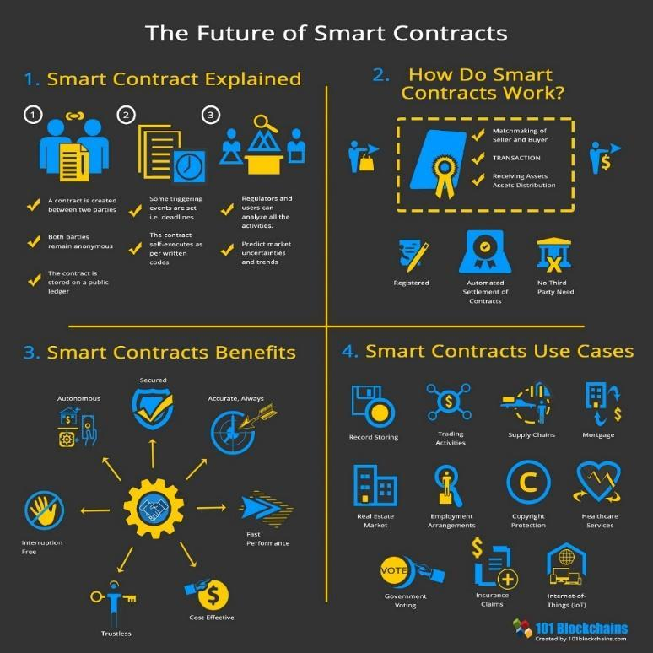

Source: 101 Blockchain

## **Stablecoins - Digital Dollar: How real-world assets are stored on the blockchain**

To reduce the pure currency risk associated with finance on the blockchain, we now elucidate one last element: crypto currencies can be tethered to US dollars or other major currencies or tangible assets like gold. This can address the concern that many digital assets like Bitcoin or Ethereum are too volatile and have no intrinsic value. Outside of the cryptocurrency enthusiasts, a small handful of well-established and regulated firms have taken it upon themselves to bring stability towards the digital asset market. The products they have brought forth are stablecoins, which can be backed by fiat currencies or by commodities. For those cryptocurrencies tethered to the US dollar, for example, some maintain a sizable reserve of dollars able to overcome (to a point) any rapid changes in price between the subject currency and the dollar. This stablecoin reserve is separate from the billions of dollars of liquidity that are already on the blockchain inside automated market makers.

Another approach is taken by Paxos, a New York State-chartered trust company regulated by the New York State Department of Financial Services. They have created products including Paxos Standard and Pax Gold (Paxos 2021), both of which use gold as a basis of value. Paxos bought a fixed supply of gold and sold the corresponding equity on digital exchanges. To maintain value, they only created the number of shares as they had ounces of gold in storage. Whatever the market price for gold is at any given time will be the price listed on the digital asset exchanges. Unlike greenbacks today (as the US is off the gold standard and Silver Certificates are long gone), holders of digital assets can redeem their shares for physical gold anytime. Thus, Paxos has created a more secure and efficient storage process for the commodity.

Having concluded a brief primer on blockchain and related crypto market factors, we now move to an application of real estate on the blockchain. The subject firm, RealT is a startup that allows anonymous knowledgeable investors to buy fractional shares (tokens) of houses and apartment buildings, using US dollars or cryptocurrency. Best of all, their basic model acquires and manages real estate without any bank debt: the deal is virtually all investor equity.

**RealT CASE STUDY**

Real T is one of several known companies (other competitors being Roofstack and Realblocks, for example) marketing fractional tokenized ownership of residential properties on the internet. RealT transactions are managed and maintained on the Ethereum blockchain. Although you can buy a RealT token with crypto currency, the US Dollar is the common currency. Thus, this case study focuses on the blockchain rather than the crypto side of innovation.

## **Demand-side: investors**

US investors must be high net worth accredited investors on the demand side as per the US Security and Exchange Commission’s (SEC) rules. Once vetted and admitted, investors can purchase property shares as they become available in the primary (like an ICO) RealT market. There is also a secondary market for shares that can be bought and sold after origination. Properties offered under SEC Regulation C to US accredited investors and to and foreign investors under Regulation S in separate tranches. Foreign investors need not hold qualified investor status. We consider Both Reg C and Reg S properties interchangeable for this case study. Investors buy "units" (tokens) of about $50 each, which is the minimum stake. If a specific property is worth, say, $65,000, about 1,300 units would be available. Each investment unit offers a stated return, i.e., 11%, payable monthly. Investors can buy as many shares as they like[2]. All rent distributions, ownership, property maintenance fund management, and other transaction-related activity are transparently available for viewing on the blockchain, and rent payments are direct-deposited via smart contracts[3]. The website employed by RealT uses public blockchain data to create an interactive dashboard for RealT investors and those curious potential investors. It provides maps, trading data, and rental disbursements (<https://dashboard.realt.ch/map>). A few examples are provided in Appendix A. RealT focuses on service to token buyers, keeping the quality of cash flows reliable and openly.

**Supply-side: RealT and originators/developers**

On the supply side, RealT is a two-year-old startup with about 70 properties in its nascent portfolio. Its primary function is to provide a bridge between independent originators and developers who list their properties on RealT's blockchain platform, thus enabling investors to access them and buy tokenized ownership equity units. The specific property is a single-family house in good condition in an inner-city neighborhood (mostly in Detroit, but a few in Cleveland, Akron, and Rochester, NY). As is generally known, because they can be bought cheaply (supply exceeds demand in many central city rust belt markets), many units are in excellent physical condition and require only modest repairs and upgrades. These units can be stabilized and then brought into the RealT portfolio as independent LLCs as fully rented and generating returns above 10%. The property transactions appear twice in the public record a few weeks or months apart: once as the originator/developer acquires the house off the market likely empty and needing repairs at a local price, and a second time when it is put into the RealT portfolio at its higher, securitized price as a renovated, fully-leased asset. While these homes can offer substantial positive cash flow, long-term appreciation is likely negligible in these markets. Once in the RealT portfolio, tenants pay rent to the LLC, a property management entity (potentially the developer but more likely a separate firm specializing in property management) that manages rent collection and deals with maintenance issues. These net funds flow onto the RealT blockchain and are distributed to unitholders per the smart contract. Exhibit 4 below shows the ownership structure and cash flow stream. The process of entering into a legally binding RealT financial agreement includes the originating LLC, tenants, management company, and RealT at the property and system levels, and of course, the token buyers. Note that Series ERC20 LLC tokens are smart contracts.

Exhibit 4: RealT System Ownership Flowchart

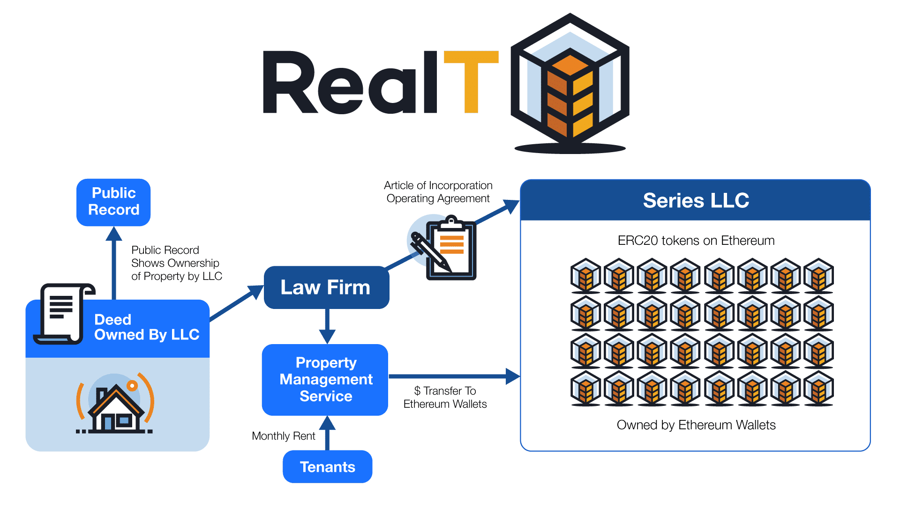

Source RealT 2021

## **The RealT portfolio**

We started tracking Real T in late November 2020. At that time, there were 19 properties in the inventory. RealT grew to 35 properties by January 20, 2021. By February 10, 2011, there were 43 properties, with several added every week or two. Our recent interview with the RealT founders revealed that they had about 70 properties as of March 5, 2021. Most of the properties are in Detroit, Michigan. Exhibit 5 shows the current RealT portfolio profile, classified as Detroit single-family homes and doubles and other multifamily units (a few apartment buildings and detached houses outside Detroit).

Exbibit 5: February 2021 RealT Listed Property Portfolio (top panel - data, bottom panel - property maps)

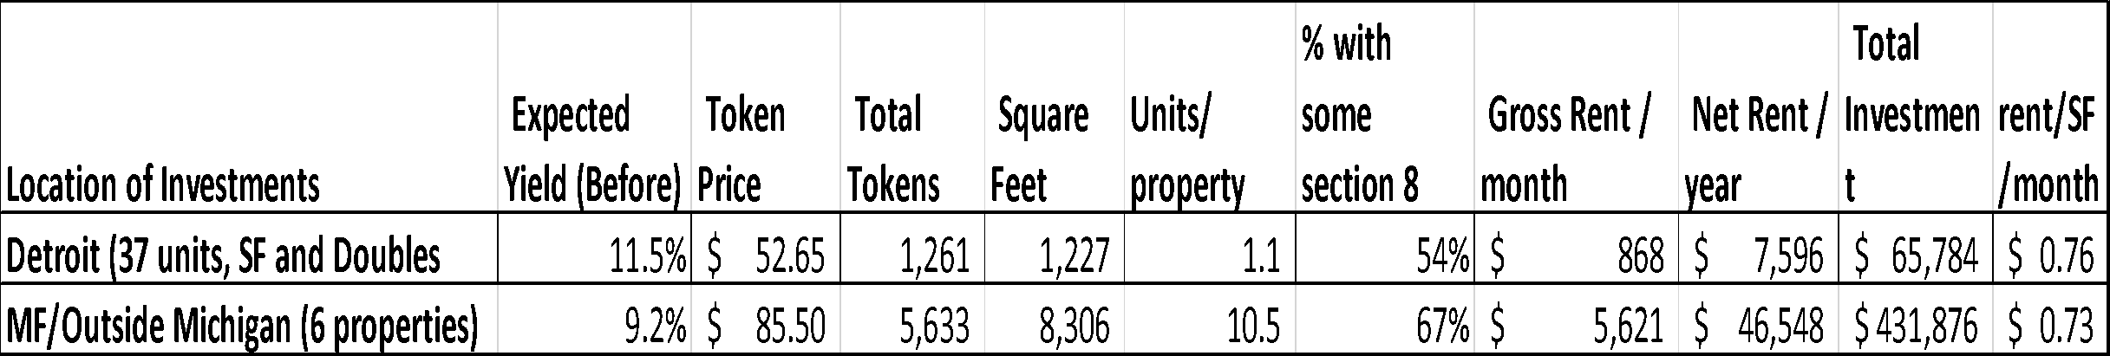

Source: RealT

The RealT portfolio is typical of an inner-city market: properties often have three bedrooms, 1.5 baths, about 1,300 square feet, are over 80 years old, and generate gross monthly rents of $870, about $0.75/SF/month. The entire tokenized price is approximately $66,000, and there are about 1,300 tokens priced at $53/token offered to investors. These tokens provide returns above 10%. Interestingly, over half of the tenants in these rentals are in the Section 8 rental voucher program. This could be very attractive to potential investors because of the stable cash flow, low turnover, offset in part by constant property maintenance costs, but generally reflecting low cash flow variability. The properties outside Detroit are small apartment buildings (average of 10 units per property), with an average unit size of about 800 square feet (SF), with similar rent and tenant profiles. Those deals had a tokenized value of about $430,000 and offered 5,600 tokens (average cost $85) per property to investors, at slightly lower but still healthy returns.

## **Acquisition and getting the property into the RealT inventory**

There are two parts to this analysis. First is the acquisition and listing of each property on the RealT blockchain, followed by its ongoing cash flows offered to investors. On the buy-side (individual property origination), the typical single-family property had a RealT syndication value of about $65,000. However, cross-checking the property on Zillow showed that the Zestimate (proprietary Zillow estimate of market value) was nearly half that or $35,000-$40,000. The same property would likely have the same rent on Zillow and in the RealT offering statement of $850 per month. Thus, it appears there is substantial upside in listing the property on RealT (basically flipping it), and the following assumptions corroborate this. Even after allowing for $10,000 for repairs and upgrades, marketing and financing costs, seeding property maintenance funds, and a one-time RealT syndication/tokenization fee of 5%, the potential lightly leveraged profit margin is about 18%, an excellent return. This is detailed later, on the top left side of Exhibit 7. RealT works closely with owners and developers, who generally do not act as property managers, which is considered a specialized field. Section 8 tenants are a niche market, with stable cash flows and high property maintenance requirements from constant government testing (Remy Jacobson 2021). These Section 8 properties require large reserves, which are sequestered on a property-by-property basis. RealT can manage the float on these funds, often at desirable interest rates (currently short-term rates in the 5-10% range), in crypto markets. At this point, RealT is selective on which properties get into their portfolio. The properties must all be leased, be in excellent physical condition, and have maintenance reserves set aside, especially if their tenants are Section 8. RealT also tries to have more than one property manager in each city as a back-up.

Once the property is listed, rents from a fully-occupied property support a projected rate of return after property taxes, maintenance, marketing, a vacancy allowance, and a Real T service fee of 2%, and a management fee of 8%, that likely accrues to an outside property management company[4]. The available net cash flow of $7,300/year is distributed in proportion to ownership in the property as shown in Exhibit 6.

Exhibit 6: Single Unit Cash Flow Example offered to Investors

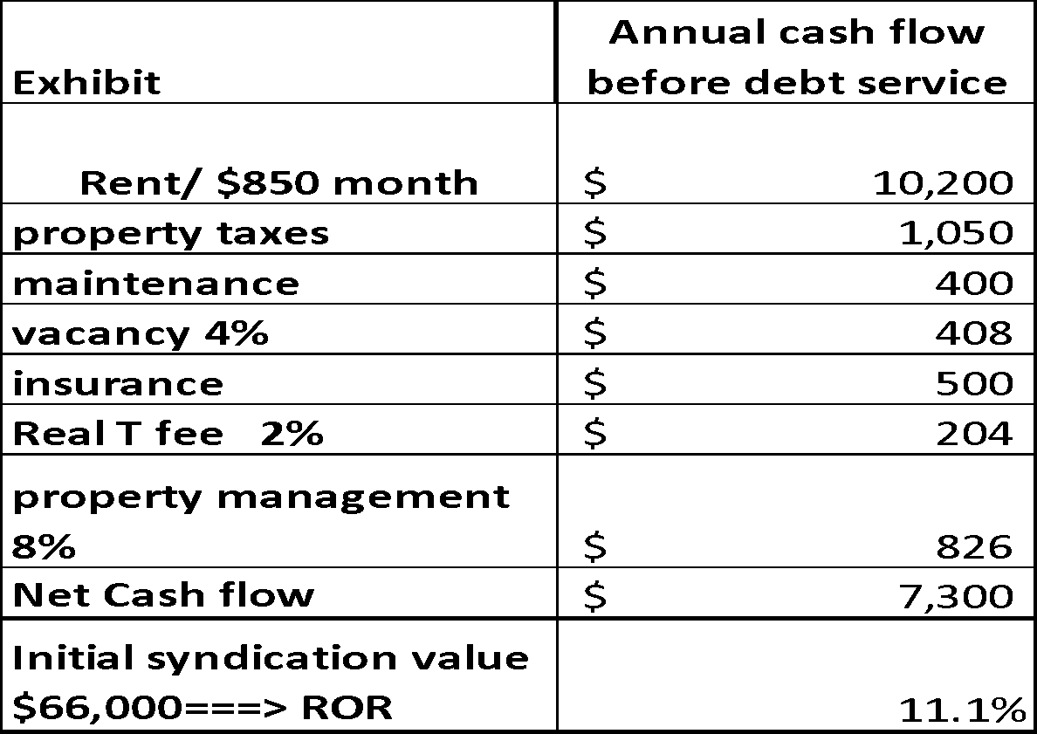

Source: RealT

## **Scalability of the RealT model**

Having set the basic assumptions, we now examine how scalable this model is for both the originator/developer and RealT, the blockchain company. For the originator/developer, we assume they operate in a metro area they know well. We assume they can select appropriate houses or apartment buildings, buy properties at or below-market prices, rehab units, obtain financing for repairs if needed, market the units, and fill them. Each unit should take three months or less to acquire, do the physical rehab work, rent up and place on the blockchain. We assume the originator/developer desires to grow the properties on RealT to achieve cash flow. The property managers also seek some economies of scale[5].

Based on these building blocks, Exhibit 7 (panels A and B) shows the scalability of the RealT model. In panel A we examine returns to the originator/developer on the left side, and the left quadrant restates material presented above in Exhibit 6 for a single unit and expands it for 10, 25, and 100 units. We address both cash flows for the original placement/development and ongoing cash flows from property management. Note that by the time the originator/developer places the property on the blockchain, they have cashed out. Unless they own tokens, they have no money left riding on the property, just the opportunity to have some entity (probably another) manage the unit for a fee. From the developer's perspective, most of the money is in listing the properties (shown above the black bottom line) rather than ongoing management (at the bottom of the left side). Each property has a nice profit (estimated at 18% using these assumptions) for "flipping" the stuff onto the blockchain. The property manager would need 100 units to net $50,000 a year on those fees. The items in red show RealT's take, both on origination and for ongoing servicing. There is also an opportunity to use floated funds for additional cash flow[6]

On the right side of Exhibit 7A, we show RealT's earnings at a larger scale since they are presumably doing this in numerous markets. Likewise, the bulk of their funds comes from the one-time-per-property listing/securitizing fee. At 1,000 units under management, the fees they would make (over $3 million) look like it could support a business nicely. Other income comes from the ongoing service fees and the float on numerous sequestered property maintenance funds, which can currently generate 5-10% returns per annum on short-term loans on the crypto markets.

In Exhibit 7B, we combine these growth scenarios over a five-year ramp-up period for both the individual originator/developer (on top) and RealT (underneath) . For the originator in each metro market, we assume a steady increase to adding up to 30 new units a year onto the blockchain, yielding about 100 total units under management by year 5. The revenues do look sustainable and could likely support a few employees, although the proportion of revenues from origination rather than ongoing management stays relatively high, at almost 90%. Further, net gains from property management are only about $60,000 a year. To make "real" money (not RealT), the entrepreneur would likely have to grow faster than we show here. On the other hand, if originator/developers tokenize apartment buildings rather than houses, or if the homes are more expensive and can still generate adequate returns such that investors would buy the tokens, the revenues would increase.

From the perspective of RealT, we assume they can add five cities (each having an originator/developer performing similar to that shown on the left side panel) a year, up to a total of 30 urban markets within five years. That gives them 900 (single family-sized) properties on the blockchain from all sources by year 5. Using these assumptions, they break $1 million by year four and have an excellent upward trajectory after that. If their originator/developers tokenize more expensive property (e.g., apartment buildings) and generate adequate returns such that investors would buy the tokens, the revenues would undoubtedly be higher.

Exhibit 7A and B: Scalability of the RealT Model

7A



7B

## 

## **SECONDARY AND INDIRECT BENEFITS OF THE RealT PROGRAM**

Detroit is not alone. Cities like Cleveland, Buffalo, and St. Louis have stable rents and declining asset values due to negative population growth. These markets can offer a high cash-on-cash return to real estate investment and quickly hit the 10% threshold attractive to online token investors. There are likely dozens of markets in the US where RealT could be replicated, and in larger markets, there could be room for more than one local originator/developer.

Since the typical Zillow market price of an asset in the RealT portfolio appears to be about 50-75% of its securitized price but rents are about the same, there are several implications. First, there is profit potential for the investor to acquire the property, get it fixed up, leased up, and flip it into the RealT online portfolio. The value-add here seems to be both the physical/rent-up and that securitizing it allows a way to find token investors that increase the asset price and still produce 10%+ returns. Nevertheless, property maintenance funds and other items dilute the return at the origination phase.

Bringing residential properties into the RealT portfolio also potentially increases property values in the inner city. These sales are legal and registered with the local authorities, and appraisers can use them as comparable sales in nearby evaluating properties. This assumes substantial appreciation or value-add between the first (original acquisition off the open market) and second (finished unit, rented and placed into a property-specific RealT LLC) transaction. Thus, this could swing the house price pendulum back toward higher values, larger mortgages, and higher net worth for owners of inner-city residential property. This is a good thing[7]. Increasing inner-city property values has been a thorny, even vexing societal issue and directly affects wealth creation among African-Americans and other minorities (Perry, 2020, Chapter 2). Buying up real estate with interested capital partners could help stabilize and redevelop neighborhoods and fuel property value appreciation. Perhaps investment in RealT could also satisfy a Bank's CRA (Community Reinvestment Act) requirements.

Another intriguing observation is the prevalence of Section 8 tenants in the RealT portfolio. This type of tenant tends to be very stable, so rental turnover is minimized. The required property quality adds a sense of oversight and assurance that the property conditions are maintained. In a sense, RealT could be looked at as a type of Section 8 secured portfolio backed indirectly by the US government. However, there are added expenses because these properties require a more extensive property maintenance budget and attention to more frequent government inspections.

# **RealT capitalizes on the structure of decentralized finance**

A major benefit of transparent blockchain investments is that all transaction data are public. Transparency in pricing assets, including buying, selling, rent payments, amounts and participants, primary market, secondary market with live secondary pricing data, and transparent visualization of dividends and liquidity in real-time. It also offers automated market makers the potential to receive profits of the bid-ask spread, where both buy-side and sell-side orders and large amounts of liquidity, including bid-ask spread, are shown. Finally, dividends paid without an ex-dividend date, where those who own at payment time receive payment, without any unwieldy prices swing to calculate expected dividends. See the last chart in Appendix A.

# **CONCLUSIONS AND FUTURE RESEARCH**

Blockchain technology is a platform for transactions and investment. It includes cryptocurrencies, of which there are dozens of investment vehicles, of which Bitcoin and Ethereum are the best known. Crypto is an emerging asset class and offers some portfolio diversification benefits, as well as attractive rates of return, subject to "translation" or conversion back into underlying currencies like the US dollar. The blockchain is a decentralized transaction system allows ease of access and transparency for financial transactions and provides a cloak of anonymity, which may be incompatible with owning real estate, which generally has ownership and transactions as public records. Everything is hidden in plain view.

This paper has provided a primer on the intersection of blockchain, cryptocurrencies, and real property. It reviews the various ways that these emerging technologies and instruments are used in real estate investment today. We provide a case study of a blockchain-oriented investment platform called RealT. Their business model and customer-servicing interface appear to be sustainable for token buying investors, originator/developer partners that list and manage the properties, and the parent company that provides a marketplace where properties are tokenized on the blockchain with smart contracts. Real estate is acquired and held with "crowdfunded" equity and no debt. This is a breaking trend in DeFi (Schär 2019). Over the next five years, the best qualities of cryptocurrency and real estate overlap and may form a robust and sustainable investment environment.

Some loose ends: We are not sure of the exit strategy for owning these houses. Perhaps you just sell your tokens, or one owner can accumulate tokens, likely at a reduced price, maybe after a non-payment event (say vacancy), above and beyond the 9.9% ownership cap. Still, it seems like the house itself is forgotten, and it's unclear if the relatively modest 5-8% management fee is enough to keep someone focused on repairs and lease-up when owners are scattered to the four winds and anonymous.

One answer may be to get neighborhood community development corporations (CDCs) groups involved. They are long-term investors in communities and developing their neighborhood with RealT could be an attractive way to build their balance sheet, get a property management fee, and build up and maintain their territory. If token prices drop, or even if they do not, CDCs could acquire them and hold ownership or even pass it off to tenants on the secondary market. Perhaps they could pool asserts and qualify as accredited investors, allowing them to acquire tokenized property under SEC regulation C.

Also, the rental property generates an annual depreciation allowance of 3.63% of the property's non-land part. This tax advantage is processed for US investors, but it is unclear if these benefits flow through to token holders in a 1099 format. For Reg S foreign investors, depreciation is left on the table, and in the future, it could be monetized by RealT at the corporate or LLC level. We are not sure how this is allocated. Maybe after income tax time, we'll find out since the author owns a few tokens in a Detroit RealT house.

While RealT founders were lukewarm on the pure profit between the first and second transactions of the originator, a careful buyer could likely beat the 18% returns in a soft housing market. Thus, the potential for upside arbitrage in house prices could be more significant than is modeled here.

Future research includes a secondary market for tokens, more volume on RealT[8], other similar firms, creating a token index, and watching to see within a few years if local house prices creep up. Finally, more thought needs to be put into the apparent fact that RealT is essentially Section 8-backed security and related implications. The future is bright for this new type of real estate finance and competition; SEC changes (for example, limiting token purchase only to accredited investors) and greater market depth seeking higher returns could move it upward by order of magnitude.

# **REFERENCES**

Adams, Hayden. 2020. Uniswap. URL*:* [*https://uniswap.org/docs/*](https://uniswap.org/docs/)

Buterin, Vitalik. 2013. Ethereum white paper. GitHub repository (2013).

CNBC, 2019. <https://www.cnbc.com/2019/08/01/goldman-spending-100-million-to-shave-milliseconds-off-stock-trades.html>

Goldman Sachs is spending $100 million to shave milliseconds off stock trades PUBLISHED THU, AUG 1 20192:15 PM EDT

(CoinTelegraph 2020). <https://cointelegraph.com/news/comparing-money-laundering-with-cryptocurrencies-and-fiat>

Comparing Money Laundering With Cryptocurrencies and Fiat JUL 30, 2020

<https://dashboard.realt.ch/map>

<https://defipulse.com/> the analytics + ranking hub for defi

<https://www.coindesk.com/bloomberg-terminal-lists-ethereum-based-debt-instrument> Bloomberg Terminal Lists Ethereum-Based Debt Instrument Updated June 5, 2019 at 12:20 p.m. EDT

<https://www.centre.io/usdc> . INTRODUCING USD COIN, A stablecoin brought to you by Circle and Coinbase, An open source, smart contract-based stablecoin

<https://www.paxos.com/paxgold/>. The safest way to own gold

<https://www.jpmorgan.com/commercial-banking/solutions/commercial-real-estate/community-development-banking/community-development-banking-faq> . Community Development Banking FAQs. Get answers to the most frequently asked questions about our community development banking business.

<https://www.policymap.com/2015/07/mapping-cra-eligibility/> . Mapping Community Reinvestment Act (CRA) Eligibility July 16, 2015 by Kristin Crandall

<https://www.curve.fi/stableswap-paper.pdf>. StableSwap - efficient mechanism for Stablecoin liquidity Michael Egorov November 10, 2019

<https://uniswap.org/whitepaper.pdf> Uniswap v2 Core Hayden Adams March 2020

<https://aave.com/>. THE LIQUIDITY PROTOCOL

Jacobson, Remy, and Jean-Marc. RealT founders, zoom interview, March 5, 2021

Leshner, Robert and Geoffrey Hayes. Compound: The Money Market Protocol. Feb. 2019. URL: [https://compound.finance/documents/Compound. Whitepaper.pdf](https://compound.finance/documents/Compound.%20Whitepaper.pdf).

Perry, Andre. 2020. Know Your Price. Washington DC: Brookings Institution Press

RealT. Legally Compliant Ownership of Tokenized Real Estate. White paper. <https://realt.co/education/> last accessed February 23, 2021.

Satoshi, Nakamoto. The Times. Chancellor on brink of second bailout for banks – the Bitcoin Genesis Block. January 3, 2009.

Schär, Fabian. 2019. <https://dx.doi.org/10.2139/ssrn.3443382>

Schär, Fabian & Schuler, Katrin & Wagner, Tobias. (2020).Blockchain Vending Machine: A Smart Contract-Based Peer-to-Peer Marketplace for Physical Goods.

**APPENDIX A: TYPES OF DOCUMENTS AVAILABLE TO RealT TOKEN HOLDERS ON THE BLOCKCHAIN IN REAL TIME**

<https://dashboard.realt.ch/map> This website uses public blockchain data to create an interactive dashboard for RealT investors and those curious. Provides mapping and trading data as well as information on rental disbursements.

Eth price changes bring volume and liquidity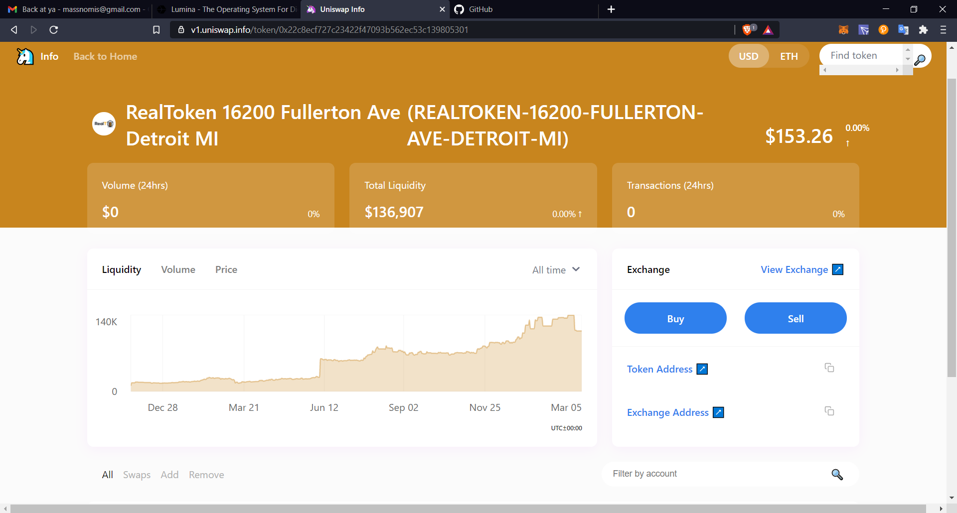

Asset transparency

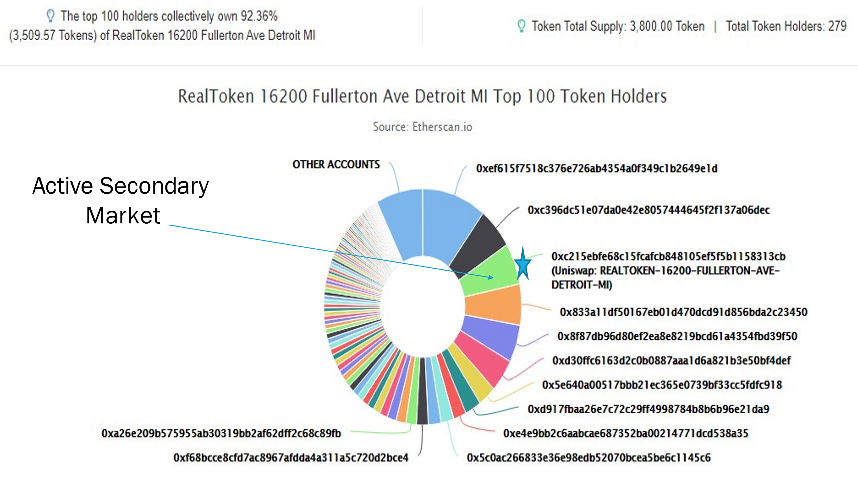

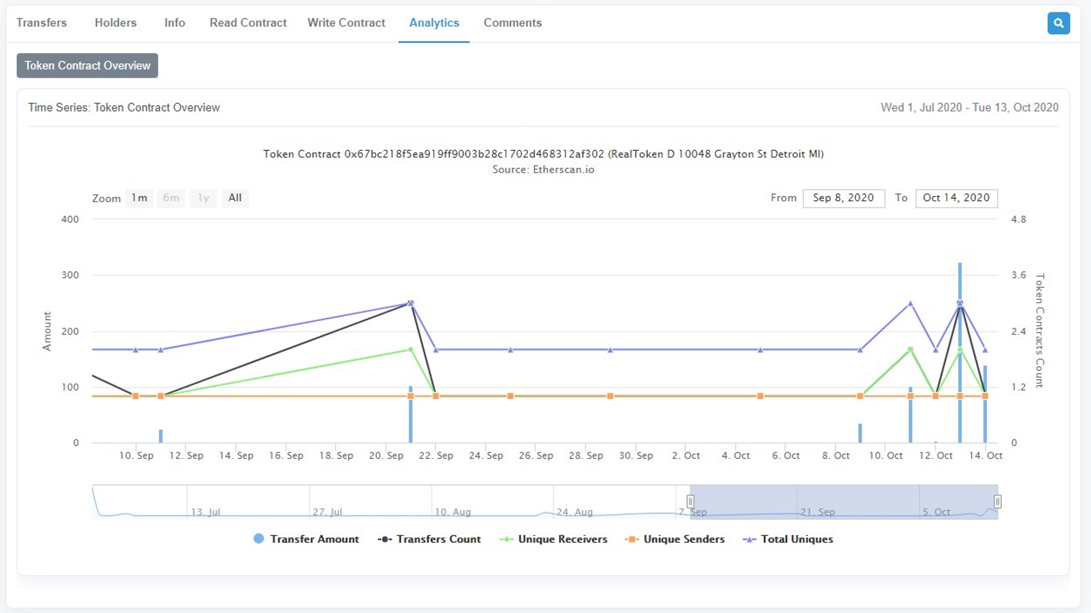

RealToken analytics; sends, trades, buys, contract interactions

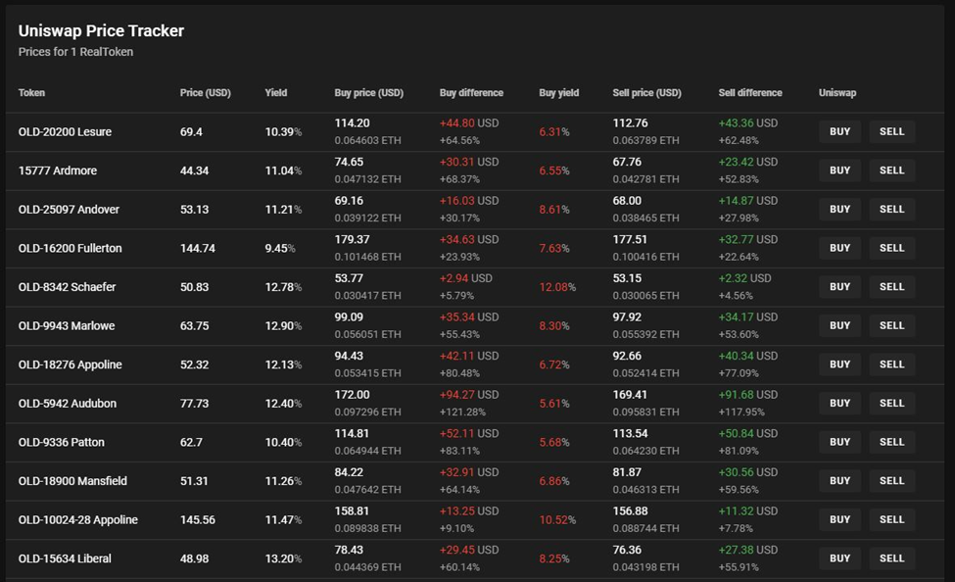

Trading dashboard, with yields included, price as bonds

1. Informal conversations with five anonymous academics at leading US universities confirmed that researching cypto currencies and blockchain, while cutting edge, is probably too risky for untenured professors. The speed of technological change, slow processing times for academic journals, and business risk in future consulting with established funders are three main reasons. There will likely be a lag before these developing elements of the financial technology field make it into the curriculum in the US.
2. At least up to 9.9% of the total number of tokens available. Further, at least at this time, RealT offers some “guaranteed buyback” provisions, though it is unclear how sustainable these are in the long run.
3. The types of reports shown in Appendix A are available to investors on ownership, distribution of cash flows and other items are remarkable and numerous. They are graph based, and show all the property’s expenditures, but everything is anonymous, as owner units are identified by numbers not by name. They are updated in real time and are remarkably transparent.
4. The RealT contract calls for a slightly lower cut, but also allows for additional management fee for distributing maintenance funds.
5. Zoom interview with Remy and Jean-Marc Jacobson, RealT Principals, March 5, 2021.
6. Defi allows for smaller investors to collectively pool capital and become a unified and profitable market maker. A Uniswap Whitepaper (Adams 2020) created the frameworks to allow for algorithmic, decentralized exchanges. Instead of utilizing order books as traditional exchanges do, Uniswap allows third parties to provide and remove liquidity to markets without government regulation or regulations. It requires a substantial amount of capital, computer and programming resources, and close connections to the exchange computer (CNBC 2019). Those who want to make money off trading can provide (loan) liquidity to a pool, essentially obtaining an annual rate of return of 5-15%, depending on their desired level of risk. RealT uses Uniswap as a core part of its secondary market, allowing for liquid, trustless, and pseudo-anonymous secondary market transactions. RealT also has an opportunity to use floated funds (from their reserves or otherwise) to buy and sell crypto for a profit, should they choose, or to provide liquidity at a handsome rate of return.
7. On the downside, if property values go up, so will property taxes, so some people will complain about that.
8. RealT is growing. As of October 2021, they have over 150 properties listed on their website, the vast majority of which are single family houses in Detroit.